Today’s Topic: Constitution 101 – The Powers of Congress
And now, your daily dose of legalese: This article does not create an attorney-client relationship with any reader. In other words, although I am a lawyer, I’m not your lawyer. In fact, we barely know each other. If you need personalized legal advice, contact an attorney in your community.
Constitution 101
This is the first installment of a new series on the U.S. Constitution – consider it Legal Lad’s contribution to the 2012 election season! For more on the Constitution, you can check out my other episodes on the Legal Lad Constitution page at QuickandDirtyTips.com, as well as my new book, The Naked Constitution: What the Founders Said, and Why it Matters.
Sponsor: The podcast version of this article is brought to you by Stitcher. With free Stitcher SmartRadio, you can listen to this and thousands of other podcasts on your mobile phone. Use promo code “Legal” and get a chance to win a cash prize.
Congress Has Two Chambers
We start our series with Congress because that’s where the Founding Fathers started: Article I of the Constitution sets out the powers of the legislative branch. The legislative branch consists of the two chambers of Congress: the House of Representatives and the Senate. Members of the House are elected every two years and they represent districts that are roughly equal in population. Members of the Senate are elected every six years, with two from every state.
The Senate is Controversial
There’s our first controversial point – every state gets the same representation in the Senate, regardless of population. Some critics regard this as anti-democratic, since it means that small states like Delaware get exactly the same representation as big states like California. However, Article V of the Constitution basically locks in this feature by guaranteeing that no state can be deprived of its equal representation in the Senate without its consent – and what state would consent to that?
It’s also worth noting that Senators were originally elected by their State legislatures. The idea was that Senators would act like ambassadors from the State governments. This only changed in 1913 with ratification of the 17th Amendment, providing for direct election of Senators. Even today, the 17th Amendment is unpopular with many who favor decentralization of power away from Washington and toward the States.
From Bill to Law
To enact a law, a bill has to pass both Houses of Congress, and get presidential approval. It usually doesn’t matter which House starts the process, but bills that impose taxes or otherwise raise revenue have to start in the House of Representatives. To get a bill passed, a simple majority – 51 percent – will generally do the trick, but there are some exceptions. For example, it takes a two-thirds majority to pass a constitutional amendment or to override a presidential veto. Perhaps the most notorious exception to majority rule isn’t in the Constitution at all: the so-called filibuster, by which one or more Senators can require a 60-vote supermajority to pass a bill, is simply a matter of internal Senate procedures. Yet another reason why the Senate is the more controversial chamber of Congress.
The “Few and Defined” Powers of Congress
You might think that the only limit to Congress’ power is its own tendency to succumb to “gridlock.” But in fact, the Constitution itself sets strict limits on Congressional reach. Article I, Section 8 sets forth an exclusive list of the subjects upon which Congress can act – generally referred to as the “enumerated powers” of Congress. Most of these powers are quite specific. For example, Congress can establish post offices, regulate the currency, issue patents, establish the army and navy, and, of course, impose taxes. In describing the Constitution, James Madison, said that the powers of the federal Congress would be “few and defined.”
The Most Important Word in the Constitution
But today, not many people would say that Congress has “few” powers. So how is it that Congress – and by extension, the federal government – has come to do so many things? The answer lies in a single word – “commerce.” One of the enumerated powers of Congress is “to regulate Commerce . . . among the several States.”
Although many people originally considered this clause to mean simply that Congress could makes rules for interstate trade, the Supreme Court in the 1824 case of Gibbons v. Ogden ruled that “commerce” in Article I should be construed more broadly to allow Congress to regulate the commercial relations among the states. This ruling gave Congress additional leeway to regulate matters that might otherwise fall within the jurisdiction of the individual states, but it took over a century for Congress to take advantage of the full potential of the Gibbons ruling.
The New Deal Expands the Powers of Congress
The Great Depression of the 1930s led to the election of Franklin D. Roosevelt, whose New Deal program involved a large expansion of federal power. In the early years of FDR’s administration, the Supreme Court actually struck down several pieces of New Deal legislation regulating things like business practices and agriculture, on the grounds that the Constitution leaves such matters up to the states, not the federal government.
The “Switch in Time”
The Supreme Court changed course in the 1937 case of NLRB v. Jones & Laughlin Steel, which upheld Congress’ power to regulate labor law – another subject that had traditionally been reserved to the states. Justice Owen Roberts, who had earlier opposed the New Deal, switched sides to support it. Some say that he did so to fend off FDR’s plan to “pack” the Court with six additional justices; thus, Roberts’ vote is sometimes called “the switch in time that saved nine” – the nine justices of the Supreme Court.
Basically, the Supreme Court said that “commerce” is a flexible word that can change with the times, and when combined with the Constitution’s proviso that Congress can pass laws “necessary and proper” to effectuate its powers, Congress has extremely broad powers to regulate matters that affect interstate relations.
The New Limits to Congress’ Power
And yet, even after the New Deal, there are still limits to Congress’ power. This was seen most recently in the Supreme Court’s decision on the Affordable Care Act, or “Obamacare” as it is sometimes called. The Court held that the Commerce Clause does not give Congress the power to require Americans to purchase health insurance; however, the Court held that Congress could impose a modest tax on people who do not have health insurance. It was only on that basis – the taxing power – that the Act was upheld. More proof that death and taxes are the great certainties of life!
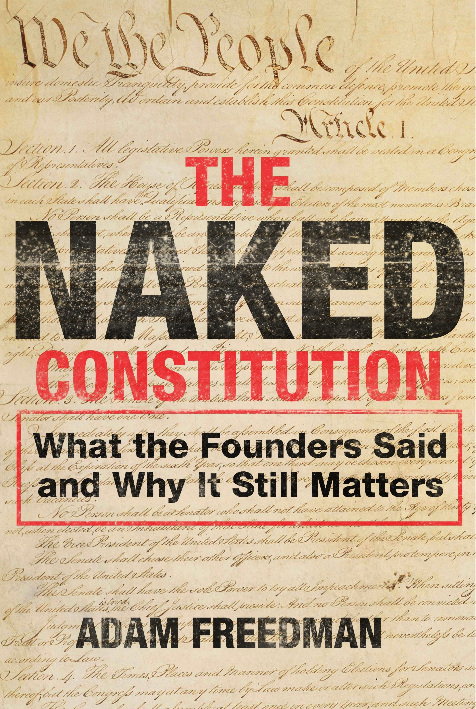
Thank you for reading Legal Lad’s Quick and Dirty Tips for a More Lawful Life.And don't forget to check out my new book, The Naked Constitution: What the Founders Said, and Why it Matters.
You can send questions and comments to legal@quickanddirtytips.com. Please note that doing so will not create an attorney-client relationship and will be used for the purposes of this article only.

